CSA 283: Exam One

Name: ______________________________________ Section: _____ _____

Please write legibly. Ask questions if something is unclear. Be concise in written answers.

You may go to Benton 002 to complete the last two questions. There you may use the Java 2 Platform Std. Ed. 6.0 documentation at http://java.sun.com/javase/6/docs/api/. You may not use any other documentation or notes unless you want to get a zero for the exam.

Some useful formulas:
d_{trans} = L/R d_{prop} = d/s

Questions:

- List the five protocol layers of the Internet in order from lowest to highest. (5 points)

_______________________, _______________________,

_______________________, _______________________,

_______________________,

- List the four sources of nodal delay and write no more than one sentence to describe each. (8 points)

_________________

_________________

_________________

_________________

- Give definitions for the following terms using one or two sentences. If the term is an acronym, also state what the letters in the acronym stand for and give a definition.
(8 points)

a. Mime encoding:

b. RFC:

c. Statistical multiplexing:

d. Traffic Intensity:

- Consider the following scenario:

You are designing a client/server application in which clients intermittently upload data to a server for storage. The server saves the data for use by an application that only runs once per week to produce a summary (assume the application runs on the same machine as the server). The application must have a complete set of all data in order to generate the summary. Which transport layer protocol would you use to support this application? Why? (5 points)

- Below is an HTTP protocol message. Answer the questions about the message.

GET /fruit/kiwi.gif HTTP/1.1
Host: www.movesinstitute.org
Connection: close
User-agent: Mozilla/4.0
If-modified-since: Wed, 01 Oct 2003 09:23:34

a. Was the message sent by a client or server? (2 points)

b. What does the header line “If-modified-since:” mean? How will this affect the response to the message? (3 points)

c. What does the header line “Connection: close” mean? Is this normal for HTTP 1.1? How could multiple objects be sent quicker? (4 points)

- List two primary advantages of circuit switching as compared to packet switching.
(4 points)

________________________________________________

________________________________________________

- Use the constants below to answer the following questions. Show work for partial credit. Indicate the units for each answer. Show times to five decimal places. Assume processing and queuing delays are negligible.

Bits being transmitted 40,000 bits
Packet Size 500 bits
Link Bandwidth 20,000 bps
Link Lengths 20,000 Meters
Propagation Speed 2.8 x 10⁸ Mps

a. Calculate the propagation delay for a single link. (2 points)

b. Calculate the transmission delay for a single packet and a single router.
(2 points)

- Assuming there are five links connected by routers and that processing and queuing delays are negligible, calculate the time required for a single packet to travel from A to B at the end of the fifth link. (6 points)
A
B

- Again, assume there are five links connected by routers and that processing and queuing delays are negligible. For pipelined transmission, calculate the time needed for the entire file to reach B at the end of the fifth link. (8 points)

- Consider the following scenario:

A network application running on frodo.nps.edu wants to transmit packets for sam.muohio.edu. In the following, assume that all DNS servers (including the local name server) use caching and that all DNS caches initially contain bare minimal information. Assume all queries are handled recursively. DNS server names are as follows:

TLD DNS server, edu: dns.tld.edu
TLD DNS server, org: dns.tld.org
Local DNS server, nps: local.nps.edu
Local DNS server, muohio: local.muohio.edu
Authoritative DNS, muohio: dns.muohio.edu
Authoritative DNS, nps: dns.nps.edu
Root DNS server: dns.root

- 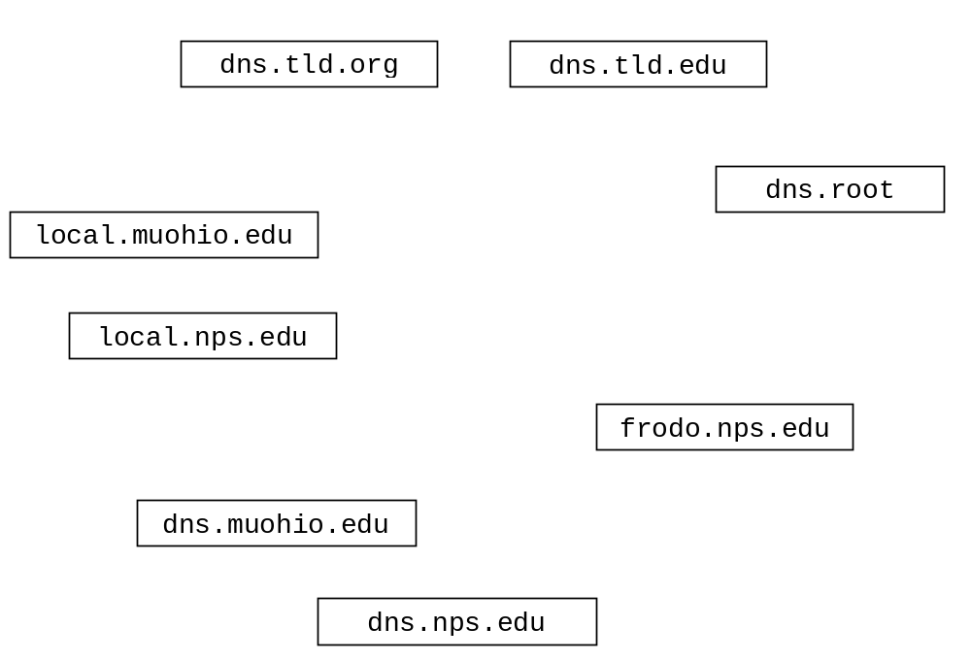Draw arrows labeled with numbers to indicate the order of queries and responses sent before frodo.nps.edu receives the IP address of sam.muohio.edu.
(12 points)

- After the sequence in part a. has occurred, suppose gandalf.nps.edu wants the IP address for merry.muohio.edu. How would the sequence of events be different? What machines would be involved?
(3 points)

- What type of resource record would actually contain the IP address of merry.muohio.edu? (circle one) (2 points)

Type A Type NS Type CNAME Type MX

- If a machine needed to send email to an address in the muohio.edu domain, what type of resource record would contain the name to the mail server for the the domain. (circle one) (2 points)

Type A Type NS Type CNAME Type MX

- An email application running on a machine with an IP address of 123.99.200.14 needs to download email messages for mr.ed@lexhorsepark.org from po.lexhorsepark.org. Name a public domain application layer protocol it might use to accomplish this task? (2 points)

______________________

In the above scenario, which host is the client and which is the server?
(4 points)

Client: _______________ Server: _______________

- Complete the Server class on the next page. Do not worry about handling exceptions. Allow the main method to throw all exceptions to the OS. (24 points)
(You may write your code on the back of a page.)
- Clients contact the Server and send one int followed by some number of floats using TCP. The absolute value of the int specifies how many floats will be sent. (java.lang.Math.abs() can be used to get the absolute value of a number.)
- The Server calculates the sum of the floats and sends the sum back to the client as a float.
- When the Server receives a negative int from a client, it will use the absolute value of it to calculate and return the sum of the floats to the client. The server itself will then close. (If the int is positive, the server will continue to run and service other clients.)
- The Server listens for clients on port number 9999.
- Do not use multi-threading. The server only needs to handle one client at a time. The Server handles clients sequentially.

import java.io.*;
import java.net.*;

public class SumServer {

public static void main(String[] args) throws Exception
{
- Complete the Server class below. Do not worry about handling exceptions. Allow the main method to throw all exceptions to the OS. (28 points)
(You may write your code on the back of a page.)
- Clients send the Server two floats in a single packet using UDP. The first float is a base. The second number is an exponent.
- The server prints out the IP address and the port number the socket the client used to send the floats
- The Server raises the base to the exponent and sends this result back to the client as a double using UDP.
- When the result is less than one, the server will return it and then close down. Otherwise the server will continue to run and service other clients.
- The Server listens for clients on port number 9999.
- The Server handles clients sequentially.

import java.io.*;
import java.net.*;
public class UDPPowerServer {

public static void main(String[] args) throws Exception
{

